Power Electronics

Improved MPPT Algorithm

Taegeon Han & Jaehee Kim, Steel Hard

06/16/23

***Abstract -* This report describes the Maximum Power Point Tracking (MPPT) used in solar systems. MPPT technology is critical to improving the performance of solar energy conversion systems. There are various algorithms of MPPT such as P&O (Perturb and Observation) and INC (Incremental Conduct). The problem with the given P&O algorithm is that the power value is not well-tracked in the rapidly changing section. In addition, there is a potential for power generation because there is an error between the estimated power and the maximum power. Therefore, we analyze various algorithms using data such as papers and find ways to reduce the error with maximum power. Then, the algorithm can be improved to analyze the cause by comparing and analyzing it with existing P&O values. We also analyze the results critically and discuss the strengths and limitations of each MPPT algorithm.**

# INTROCUCTION

T

his report will optimize the efficiency of solar energy conversion in solar systems using the MPPT algorithm. Until now, the world has caused global warming due to the use of numerous fossil fuels. Renewable energy such as wind energy and solar energy have emerged to replace this, and are continuing to develop. Fossil fuels, an energy source that are still heavily dependent on, are limited in amount, but renewable energy is not limited in amount and is almost harmless to the environment. Therefore, as demand continues to increase, it is emerging as a sustainable solution.  
Among new and renewable energy, we will talk about solar systems. It converts solar energy into electrical energy, and it's important to extract maximum efficiency. Although there are algorithms such as PV, inverter, MPPT, etc. to improve solar system efficiency, this report mainly uses the MPPT algorithm. Compared to other algorithms, it has high efficiency of MPPT algorithm. However, we will think about ways to reduce the error with the maximum power point by thinking of ways to further improve its efficiency. As the amount of insolation increases, the short circuit current and the maximum power point (MPP) increase. And as the temperature rises, the open voltage decreases and the MPP decreases. We will use the above two features to estimate the maximum power point. The main objective of the MPPT system is to maximize power output and improve overall system efficiency by continuously tracking and adjusting the operating points of the solar panels and maintaining them in the MPP. The existing MPPT method is optimized for static conditions, so it is not able to respond well to rapidly changing environments. However, rapid maximum power follow-up must be accompanied to respond to dynamic environmental changes such as fluctuations in solar radiation, which change rapidly. Because real-time solar radiation changes, an improved MPPT method is needed to increase the efficiency of the solar power generation system. First, MPPT has algorithms such as Perturb & Observer (P&O), Incremental Induction (IC), and FOCV (Fractional open circuit voltage), but among them, we will improve P&O and FOCV to improve efficiency. Explain simply, the P&O algorithm is a method of finding MPPT by comparing the current value with the previous value by varying the solar array voltage ($V_{sa}$). This method is easy to implement, but under rapidly changing conditions, the operating point may move away from the MPP and vibrate around the MPP, causing energy loss. The FOCV is an MPPT using the relationship between the voltage of the open circuit and the maximum power point. This method responds well to rapidly changing conditions, while FOCV may struggle to track the MPP accurately during low irradiance or partial shading scenarios. Therefore, overcoming and improving their respective limitations and increasing efficiency.



Figure 1. Solar Panel

# PHYSICAL MODEL PARAMETER

To verify the performance of the P&F MPPT proposed in this paper, data from the PV panel (Kyocer_KC175GHT-2) installed on the campus of Handong University were used. The PV panel characteristics are shown in Table 1 below.

|  |  |  |
| --- | --- | --- |
| Parameter | Symbol | Value |
| Max solar intensity | $$E_{0}$$ | $$1000[W/m^{3}]$$ |
| Open circuit voltage from datasheet | $$V_{OC0}$$ | $$29.2[V]$$ |
| Short circuit current from datasheet | $$I_{SC0}$$ | $$8.09[A]$$ |
| Diode Saturation current from V.L.Brano | $$I_{S0}$$ | $$1.4356×{10}^{-11}[A]$$ |
| Temperature coefficient from datasheet | $$C_{t}$$ | $$3.18×{10}^{-3}[A/℃]$$ |
| Reference temperature | $$T_{ref}$$ | $$298[K]$$ |
| ideal factor multi-crystal from material data | $$A$$ | $$1$$ |
| Number of cells from datasheet | $$Cell$$ | 48 |
| Band energy from material data | $$B_{g}$$ | $$1.12[eV]$$ |
| Operation temperature coefficient from datasheet | $$K_{s}$$ | $$0.0275[W/m^{3}/℃]$$ |
| Electron charge | $$q$$ | $$1.6×{10}^{-19}$$ |
| Boltzman constant | $$k$$ | $$1.3806505×{10}^{-23}$$ |
| Diode voltage drop | $$V_{d}$$ | $$0.5[V]$$ |
| Parallel resistance from equivalent circuit | $$R_{sh}$$ | $$99.158[Ω]$$ |
| Series resistance from equivalent circuit | $$R_{s}$$ | $$99.158[Ω]$$ |

Table 1. Kyocer_KC175GHT-2 Parameter



Figure 2. Photo of solar panels installed at Handong University

# BASIC PRINCIPLE OF SOLAR PANEL

1. Principle of solar panel

The principle of solar panels is based on the photoelectric effect. The photoelectric effect is a phenomenon in which when light collides with a specific material, electrons are activated inside the material and converted into electrical energy. Using this principle, solar panels receive sunlight and generate electricity. Typically, a solar panel consists of several solar cells. Solar cells are typically made of silicon, a semiconductor material, and consist of an anode and a cathode, where electricity flows from these two poles.

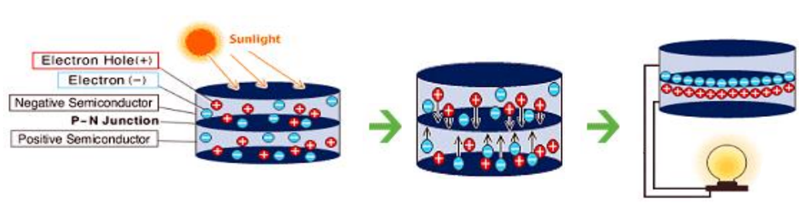

Figure 3. Principle of solar panel

More specifically, when sunlight touches the surface of the solar panel, it is absorbed into the semiconductor material on that surface. In this process, electrons are freed from the restriction of the nucleus and the electrons are activated. Then, the hole and the electron move to the p-n junction, and the electron and the hole are separated and an electric field is formed. Thus, an electrical difference occurs between the positive and negative poles, through which electrons flow through an external circuit. Therefore, solar panels can generate direct current using this principle and convert it into alternating current using devices such as inverters. Figure 1 shows this principle visually.

1. Effect of solar radiation

Characteristics of solar cell curve according to solar radiation change. Solar radiation means the amount of solar energy received per unit area. Therefore, the higher the solar radiation level, the higher the power output of the solar panel. In other words, bright direct sunlight provides the highest energy conversion rate. Cloudy weather or cloud conditions reduce solar intensity and reduce power generation. Figure 2 is a solar cell curve, a current-voltage curve, and shows the relationship between current and voltage with solar radiation. As the amount of insolation increases, the open circuit voltage $V_{oc}$ and the short circuit current Isa increase. Conversely, when solar radiation decreases, $V_{oc}$ and $I_{sa}$ decrease. For $V_{oc}$, this is because higher levels of solar energy result in more electron-hole pairs being generated within the cell, leading to an increase in the voltage potential. In the case of Ioc, as insolation increases, more photons are absorbed by the solar cell, leading to a higher generation rate of electron-hole pairs and an increase in the short circuit current. Therefore, an increase in solar radiation moves the maximum power point (MPP) to higher current and voltage values, indicating an increase in maximum power output.

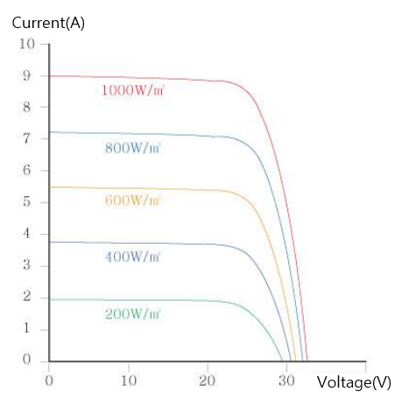

Figure 4. Solar Radiation Change Effect

1. Effect of temperature

Next, the effect of temperature. Temperature affects the movement of the charge carrier and the efficiency of the energy conversion process, affecting the performance of the solar cell. Figure 3 is a solar cell curve, a current-voltage curve, showing the relationship between current and voltage over temperature. As the temperature increases, $V_{oc}$ and Isa decrease. Conversely, as the temperature decreases, $V_{oc}$ increases. In the case of $V_{oc}$, the higher the temperature, the higher the thermal energy of the charge carrier, the lower the potential difference across the cell. For $I_{oc}$, high temperatures can increase the rate of generation of electron-hole pairs, but lead to an increase in recombination rates, resulting in a decrease in $I_{sc}$. Therefore, as the temperature increases, the MPP switches to a lower voltage value due to a decrease in Voc. However, the change in current due to temperature is generally smaller, so the effect on MPP is relatively small.

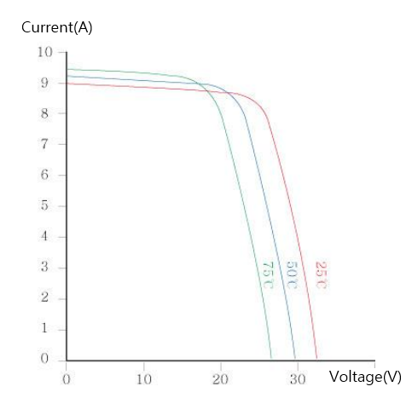

Figure 5. Temperature Change Effect

# MPPT OPERATION

Solar cells, also known as photovoltaic (PV) cells, are devices that convert sunlight directly into electricity through the photovoltaic effect. The basic principles of solar cells involve the interaction of light with semiconductor materials.

The solar cell circuit consists of a solar cell panel and a power conversion device. This power conversion device is used in solar power systems to regulate and optimize the electricity generated by the solar cells. DC-DC converter helps improve the overall efficiency of the system by maximizing power transfer and providing stable output voltage.

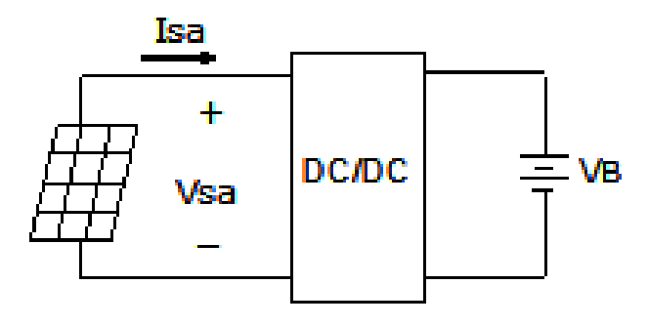

Figure 6. Solar Array with DC-DC converter

In general, a solar array is connected with a load to use energy or is connected with a battery to store energy. This report uses the Solar Array+Battery model. In a solar power system that includes solar arrays and batteries, the solar arrays generate electrical energy from sunlight, and the batteries store that energy for later use.

Solar panels have a characteristic voltage- current (V-I) curve, which shows the relationship between the current and voltage output of the panel. The operating point of the system is determined by the intersection point of the solar array's V-I curve and the battery's constant voltage level.(Figure 2)

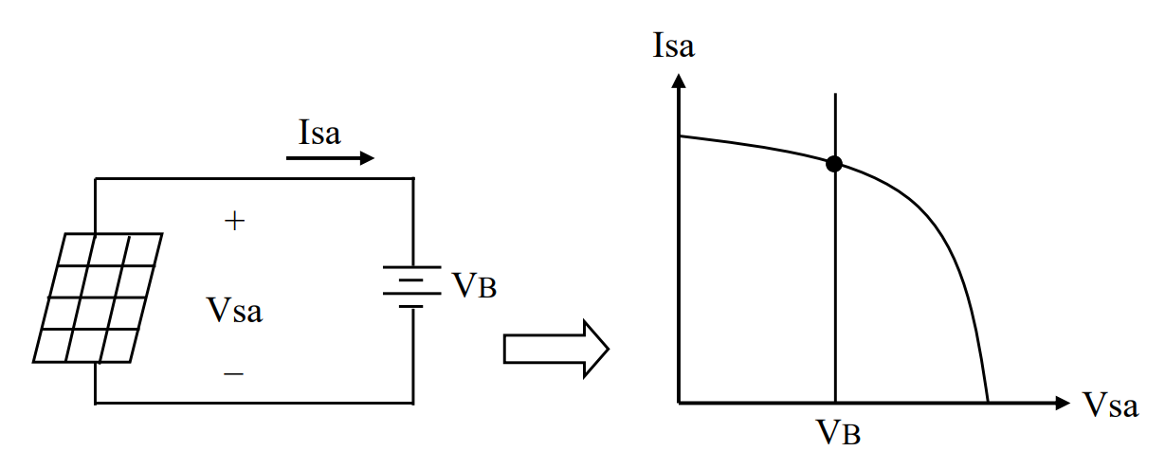

Figure 7. Solar Array and Battery Circuit Operating Point

As described above, the shape and position of the V-I curve of the solar panel vary depending on solar radiation and temperature. How these characteristics appear in the voltage-power graph will be described below.

First, the intensity of solar radiation has a significant impact on the Solar Array V-I Curve. When the solar radiation increases, more photons (particles of light) reach the solar cells in the array, resulting in a higher current output. As a result, as shown in Figure 3, the V-I curve shifts upward, indicating higher current values at various voltage levels. Conversely, when solar radiation decreases, such as during cloudy or shaded conditions, fewer photons reach the solar cells, leading to a decrease in the current output. This shift in the V-I curve occurs downward, indicating lower current values at different voltage levels.

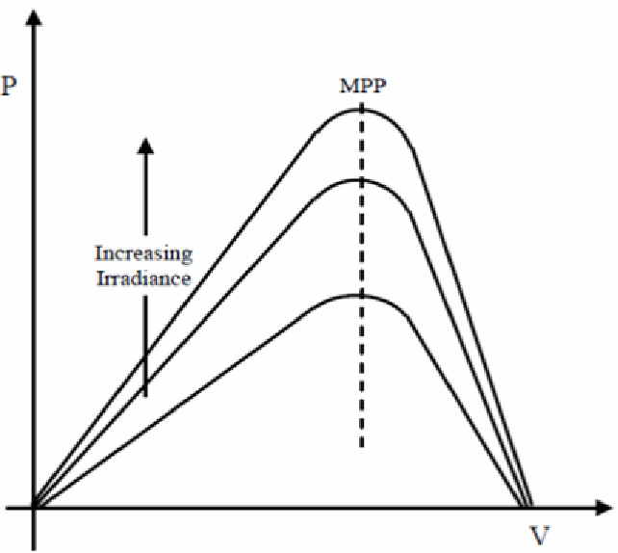

Figure 8. Variation of MPP with changing irradiance

Secondly, temperature also affects the Solar Array V-I Curve. As shown in Figure 4, with increased temperature, the V-I curve shifts downward, indicating lower current values at different voltage levels. This shift is a result of reduced electron-hole pair generation and increased recombination of charge carriers within the solar cells. It's important to note that the exact impact of temperature on the Solar Array V-I Curve depends on the specific characteristics and materials of the solar cells used in the array. Different types of solar cells exhibit varying degrees of sensitivity to temperature changes.

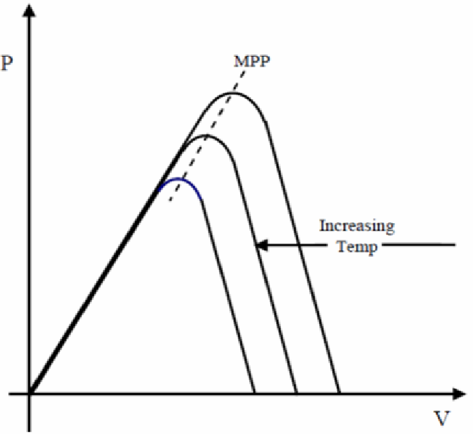

Figure 9. Variation of MPP with changing temperature

The power-voltage (P-V) graph derived from the V-I curve shows the relationship between the power output (P) and voltage output (V) of the solar array. The power-voltage graph generally exhibits a distinctive shape, with a peak corresponding to the MPP. The MPP represents the operating point where the solar array generates the maximum power output for a given set of conditions.

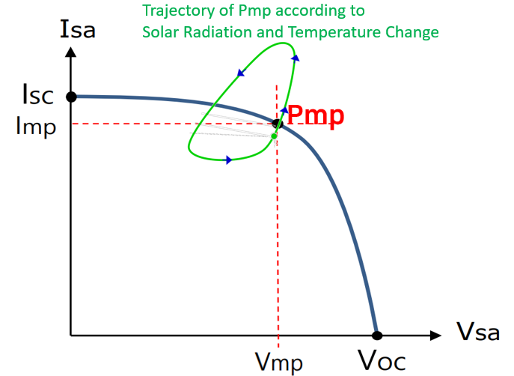

Figure 10. Trajectory of Pmp according to Solar Radiation and Temperature Change

Overall, changes in solar radiation and temperature result in shifts in the Solar Array V-I Curve. These shifts can impact the position of the MPP on the curve, which represents the optimal operating point for power output.

To account for these variations and maintain the system operating at the MPP, maximum power point tracking (MPPT) algorithms are employed in solar power systems. MPPT systems continuously monitor and adjust the solar array's voltage and current output to ensure that the array operates at its MPP, regardless of changes in solar radiation and temperature.

By tracking and adjusting for these changes, the MPPT system ensures that the solar array consistently operates at its highest efficiency, extracting the maximum available power from the sunlight and optimizing energy conversion. This approach allows for better utilization of solar energy and improves the overall performance of the solar power system. Figure 6 shows the basic topology of a photovoltaic (PV) system. It consists of a DC/DC converter, load, PV module, and the MPPT control unit.

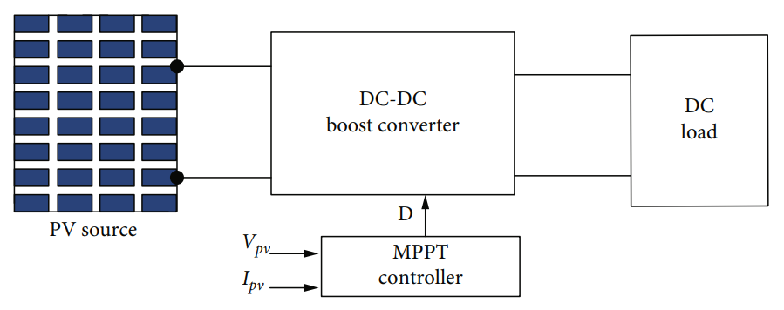

Figure 11. Photovoltaic system

# GENERAL RESERCH

1. Perturb & Observe Algorithm

P&O MPPT, which stands for Perturbation and Observed Maximum Power Point Tracking, is a widely utilized technology for optimizing the performance of solar photovoltaic (PV) systems. Its main objective is to track and maintain the maximum power point (MPP) of the solar panel, where the system operates most efficiently and generates the highest amount of power.

The P&O MPPT algorithm(Figure 7) achieves this by distorting the operating point of the PV system and observing the resulting power output. It does this by making small adjustments to the operating conditions and measuring the change in power before and after each adjustment, known as perturbation. The algorithm determines the direction of the perturbation based on the observed power difference. If the power difference is positive, indicating an increase in power output, the algorithm continues in the same direction. If the power difference is negative, suggesting a decrease in power output, the algorithm reverses the perturbation direction.

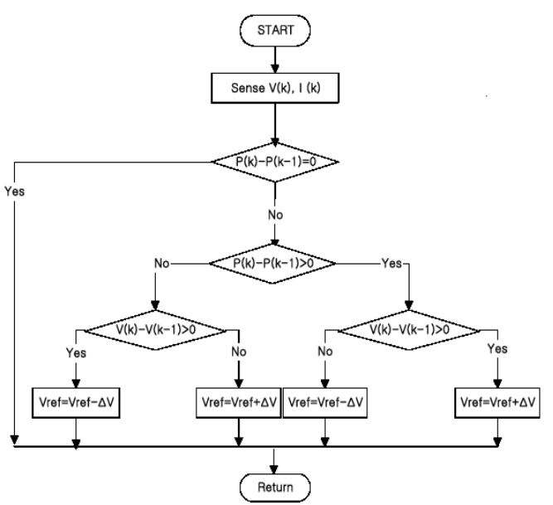

Figure 12. Flowchart of the P&O algorithm

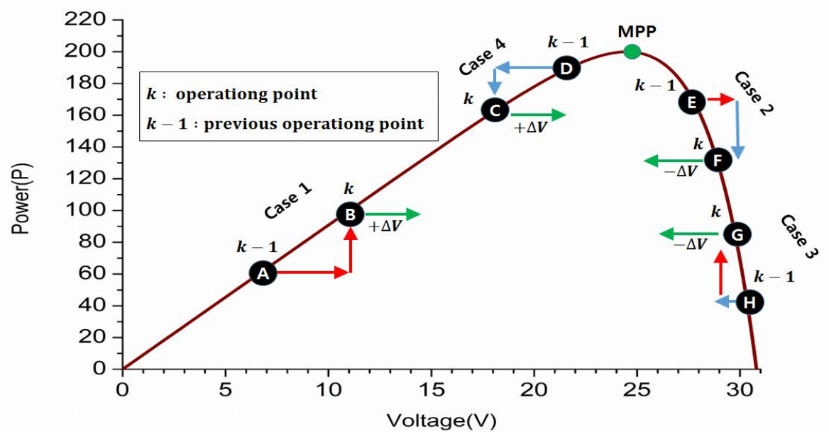

Figure 13. The characteristic of P&O MPPT

1. FOCV Algorithm

FOCV MPPT, which stands for Fractional Open Circuit Voltage Maximum Power Point Tracking, is a technique utilized in photovoltaic (PV) systems to optimize the energy production from solar panels. Its primary objective is to ensure the PV system operates at its maximum power point (MPP), which corresponds to the voltage and current combination that yields the highest power output.

The FOCV method is a specific MPPT algorithm employed in PV systems. Unlike other MPPT techniques that directly measure the current and voltage of the PV panel, FOCV MPPT estimates the MPP voltage by monitoring the open-circuit voltage (Voc) of the panel. By analyzing the open-circuit voltage, the FOCV MPPT algorithm adjusts the operating parameters of the PV system to maintain it at the MPP, maximizing its power generation potential.

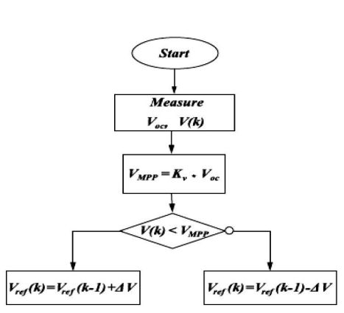

Figure 14. Flowchart of the FOCV algorithm

# PROBLEM DEFINITION

1. Perturb & Observe Algorithm

One of the limitations of the P&O algorithm is the fixed step size used for perturbing the operating point. When the step size is fixed, it may not be optimal for all conditions. In particular, when the operating point is near the MPP, the fixed step size can lead to oscillations or "vibrations" around the MPP as shown in Figure 15. This occurs because the algorithm alternates between increasing and decreasing the operating point by the fixed step size, causing the system to continuously move back and forth around the MPP without effectively reaching it.

These vibrations can result in a loss of power generation efficiency because the PV panel does not operate at the true MPP. Instead, it operates in a suboptimal region, leading to reduced power output. The fixed step size limitation of the P&O algorithm makes it more susceptible to these vibrations, especially under rapidly changing environmental conditions or when the MPP is difficult to track precisely.

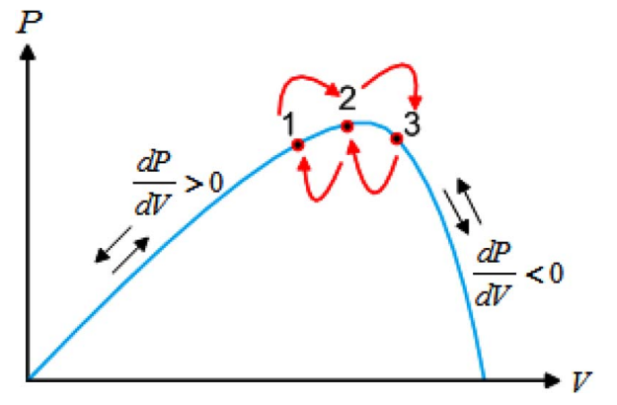

**Figure 15. Vibration near MPP of P&O Algorithm**

Another problem associated with the P&O algorithm is its susceptibility to false followings when there are sudden weather changes, such as variations in solar radiation. The algorithm determines the perturbation direction based on the observed power differences between consecutive iterations. However, these power differences can be influenced by factors other than the actual change in the MPP.

During weather changes, the power output of a PV panel can fluctuate due to factors like cloud cover, shading, or partial obstructions. These fluctuations may not necessarily reflect a change in the MPP but can still affect the observed power differences used by the P&O algorithm. As a result, the algorithm may mistakenly perceive these power variations as a change in the MPP and adjust the operating point accordingly.

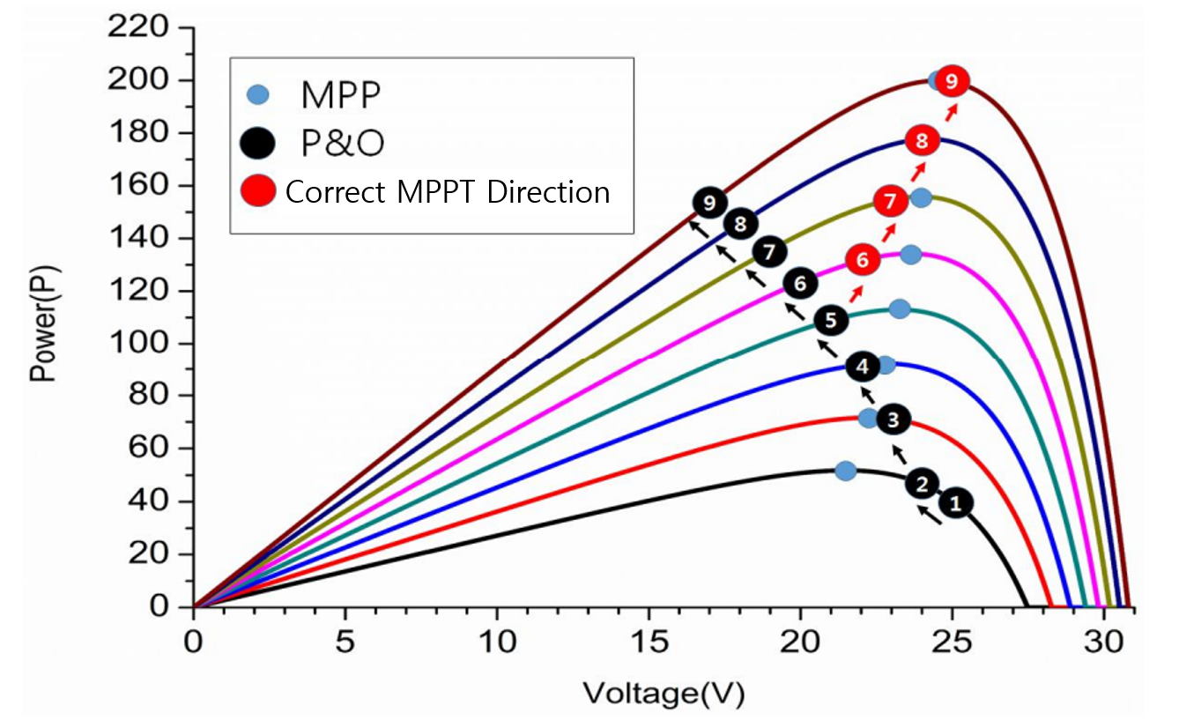

Figure 16. P-V characteristics Curve under increasing irradiance

1. FOCV Algorithm

The FOCV algorithm assumes a linear relationship between the open-circuit voltage and the MPP voltage, which may not hold true under varying temperature conditions. Temperature changes can significantly impact the performance of solar panels, causing the FOCV algorithm to provide inaccurate MPP voltage estimates. For instance, if the temperature increases, the actual MPP voltage may be lower than the estimated value, leading to suboptimal power output.

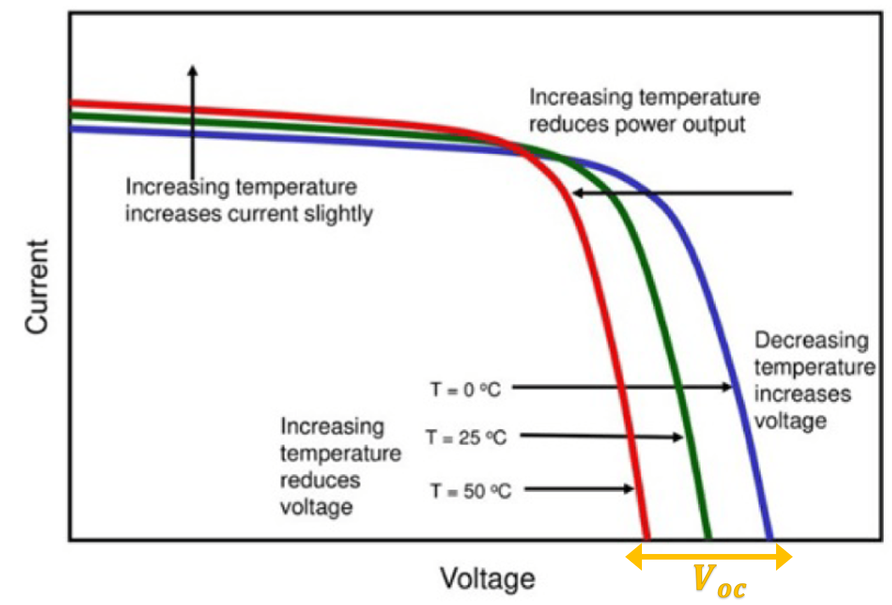

Figure 17. Sensitivity to temperature changes of P&O Algorithm

In addition, the FOCV method has a problem that occurs because the PV panel has nonlinear characteristics. Photovoltaic panels exhibit non-linear characteristics due to factors such as shading, aging, and partial cell illumination. The FOCV algorithm's reliance solely on open-circuit voltage may not effectively capture these non-linearities, leading to inaccurate MPP voltage estimation. In scenarios where partial shading occurs on a PV module, the FOCV algorithm may mistakenly identify the local MPP instead of the global MPP, resulting in reduced overall power generation.

# PROPOSED IDEA

Looking at the presentation of group 1 among the presentations of various groups, it was confirmed that FOCV could compensate for the shortcomings of P&O that could not be well estimated from rapid fluctuations. Therefore, we decided to combine P&O, which tracks MPP points well, and FOCV, which responds well to rapid changes. Multiply the V_oc value by a certain percentage to determine a certain range using variables of W and Z. We don't keep calculating $V_{oc}$ and W and Z, but we also fix W and Z by fixing $V_{oc}$. If the measurement falls within the range between W and Z, it acts as a more accurate estimation of P&O.

On the other hand, we devise an algorithm that finds MPP by operating with a faster responsiveness FOCV and allowing it to enter between W and Z quickly. This not only allows better tracking of MPPs, but also allows you to adjust the size of the steps to adjust the vibration. It was named P&F as an algorithm created by combining and improving P&O and FOCV. Since it is a newly created algorithm, we tried simulating with various values to continue to set the range of W and Z. The values found are not optimal, but we can see that the error is reduced more than the previous algorithm. Therefore, we expect that it will improve further if we find only the optimal point.

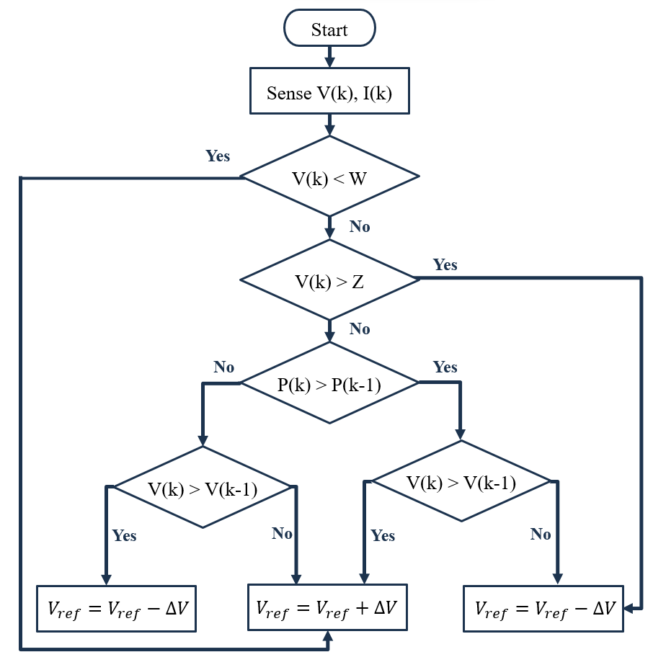

Figure 18. Flowchart of the P&F algorithm

# RESULT

The following is the result of the simulation using the PSIM program for each algorithm. Simulation data used full-day temperature, solar radiation data for five days seasonally in 2022.

1. MPPT Simulation Result using P&O Algorithm

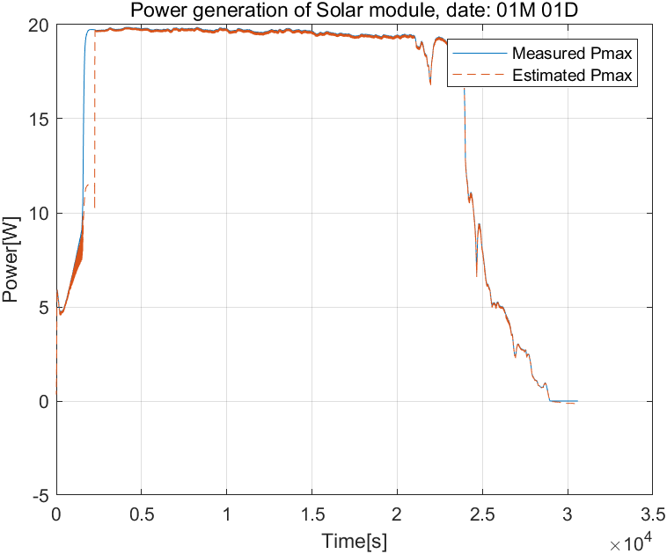

Figure 19. Simulation Result on January 1st using P&O

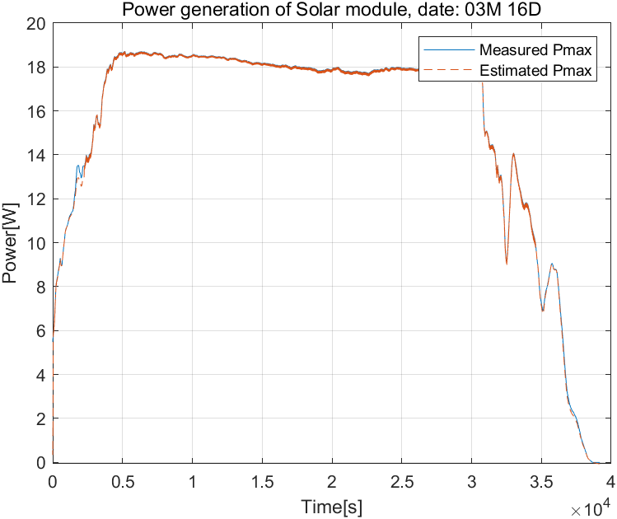

Figure 20. Simulation Result on March 16th using P&O

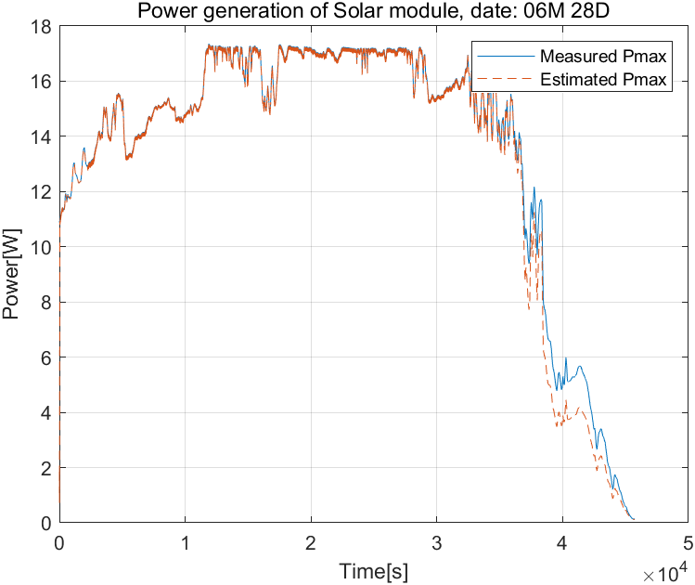

Figure 21. Simulation Result on June 28th using P&O

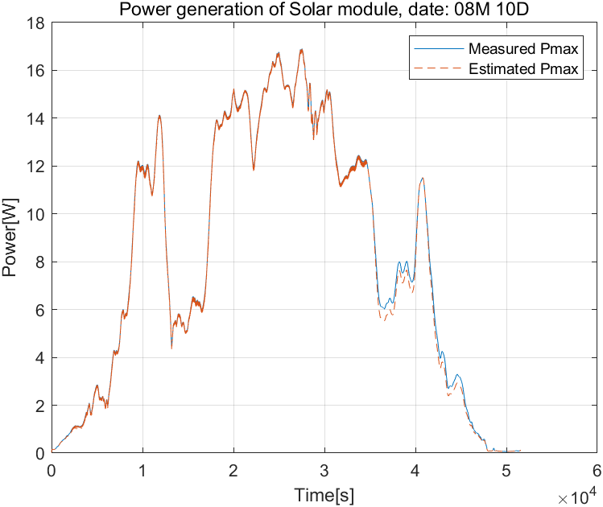

Figure 22. Simulation Result on August 10th using P&O

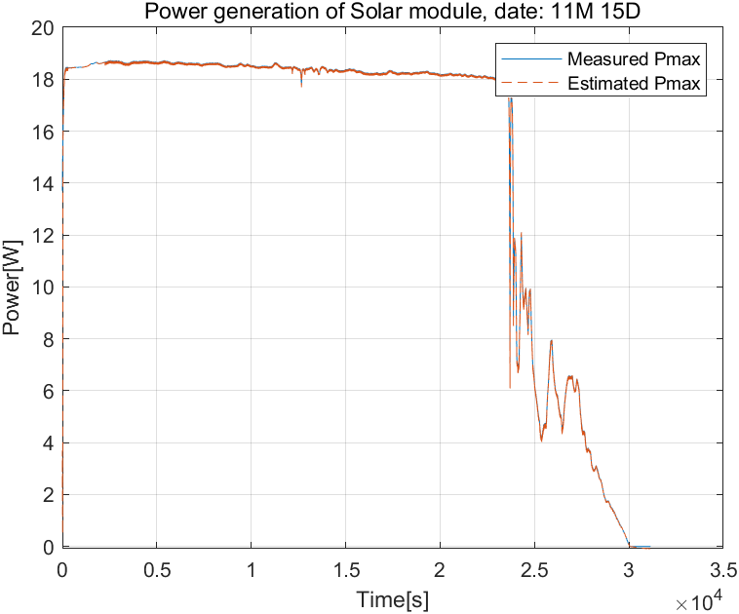

Figure 23. Simulation Result on November 15th using P&O

1. MPPT Simulation Result using P&F Algorithm

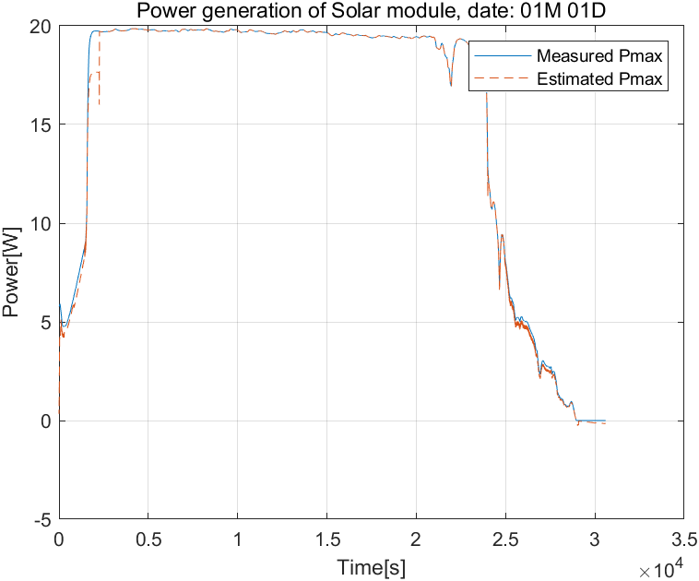

Figure 24. Simulation Result on January 1st using P&F

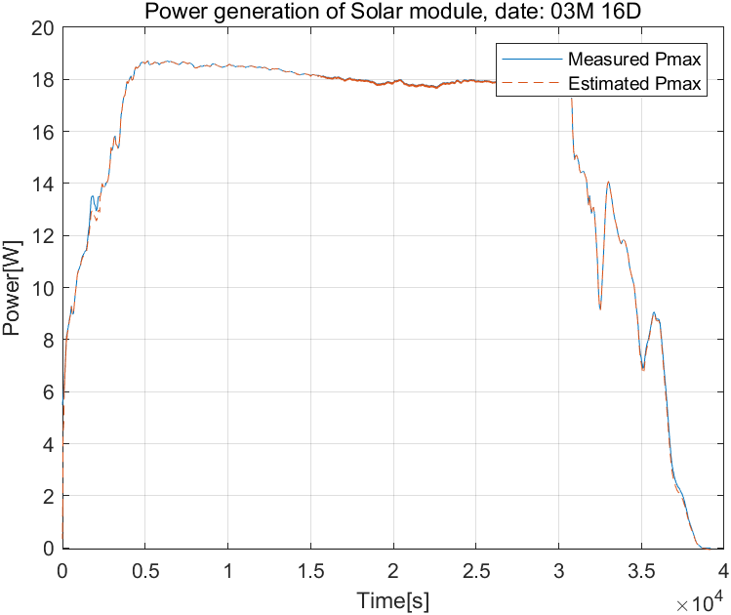

Figure 25. Simulation Result on March 16th using P&F

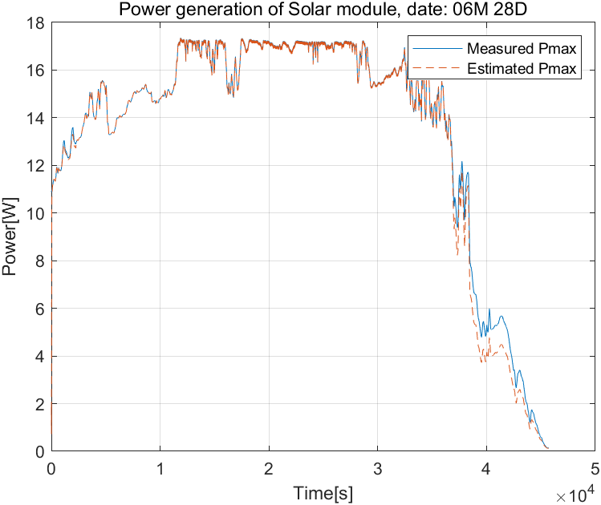

Figure 26. Simulation Result on June 28th using P&F

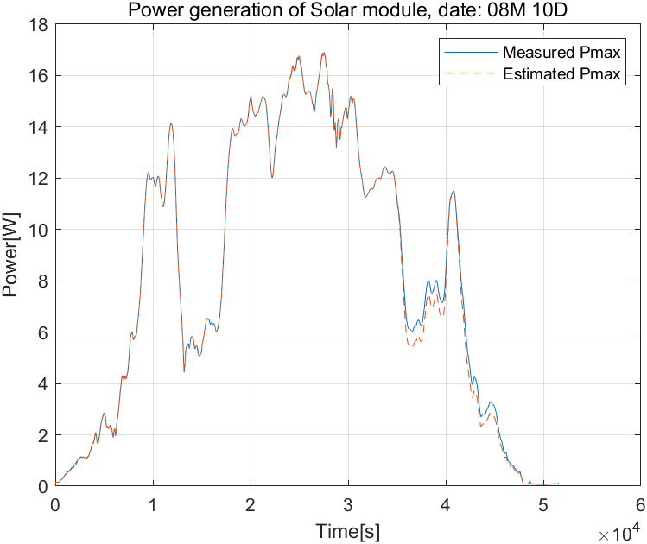

Figure 27. Simulation Result on August 10th using P&F

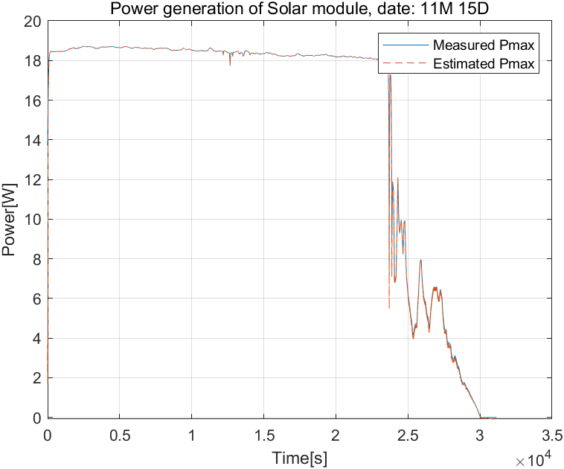

Figure 28. Simulation Result on November 15th using P&F

1. MPPT Simulation Result Error Calculation

The accuracy of MPPT estimation can be evaluated through the sum of the differences between the actual Pmax and the estimated Psa. The following is an equation for estimation accuracy evaluation.

$$P_{sa}=V_{sa}×I_{sa}$$

$$Error=\sum{P_{max}-P_{sa}}$$

|  |  |  |  |
| --- | --- | --- | --- |
| Date | P & O (A) | Improved  P & O (B) | Error  (A – B) |
| January 1 | 7.3676e+03 | 3.2379e+03 | |  | | --- | | 4.13E+02 | |
| March 16 | 2.2448e+03 | 1.4147e+03 | 8.30E+02 |
| June 28 | 1.1636e+04 | 8.5593e+03 | 3.08E+03 |
| August 10 | 5.4183e+03 | 5.3301e+03 | 8.82E+01 |
| November 15 | 1.3925e+03 | 1.0132e+03 | 3.79E+02 |

Table 2. Simulation Error Calculation

# DISCUSSION

1. Principle of solar panel

The step size is a crucial parameter in Maximum Power Point Tracking (MPPT) algorithms, which play a significant role in maximizing the power output of photovoltaic (PV) systems. The step size parameter determines the magnitude of the perturbation or adjustment made to the operating point during the MPPT process. While learning and practicing MPPT, the step size was designated as 1, and kept changing the size to improve it. As a result, a small step size allows for fine adjustment of the operating point, resulting in accurate tracking but slower convergence. On the other hand, a large step size facilitates faster convergence but may lead to oscillations around the MPP. Therefore, selecting an optimal step size is crucial to achieve a balance between tracking accuracy and convergence speed.

1. MPP tracking error in P&O

The P&O algorithm does not track MPP values well when rapid environmental changes occur. Therefore, you can see that there is a large error at the beginning of the data on January 1st. The P&O algorithm is not fast enough to keep up with rapid changes in responsiveness. This results in temporary power loss or reduced efficiency for a temporary period of time, falling behind in reaching a new MPP. Another characteristic of P&O is that vibration occurs around MPP. Constantly overshooting and undershooting MPPs, making it difficult for algorithms to accurately reach real MPPs. This affects the overall efficiency of the system. Therefore, we gave a variable step size to increase tracking accuracy and reduce vibration. You need to adjust this value to find the best value for accuracy and efficiency improvement.

# CONCLUSION

In this report, we analyzed the P&O (Perturb & Observer) algorithm and the FOCV (Fractional Open Circuit Voltage) algorithm in Maximum Power Point Tracking (MPPT), which is widely used for solar systems. Both algorithms have advantages and considerations, and the combined approach can provide improved MPPT performance. We combine the two algorithms to improve MPPT performance and efficiency, reducing the error values of maximum power and estimated power. P&O is simple and easy to implement, but it shows vibration and low precision under rapidly changing conditions. On the other hand, FOCV is useful in changing environmental conditions by showing faster tracking speed and greater accuracy when reaching Maximum Power Point (MPP). FOCV and P&O were combined and supplemented to compensate for each other's shortcomings. The FOCV algorithm continuously adjusts the operating point of the PV system to match the MPP, and is fine-tuned and tracked by the P&O algorithm. This approach can improve the accuracy of MPP tracking under various environmental conditions and reduce vibration around maximum power through value adjustment. Compared to each algorithm, the combination and improvement of the two algorithms make it more complicated by additional calculations, but improvements in performance can be seen. Nevertheless, there is still an error between maximum and estimated power, so it can be improved better.

# WORK DISTRIBUTION

|  |  |  |
| --- | --- | --- |
|  | Taegeon Han | Jaehee Kim |
| Circuit construction | 50% | 50% |
| Circuit Testing | 50% | 50% |
| Report | 50% | 50% |

# APPENDIX

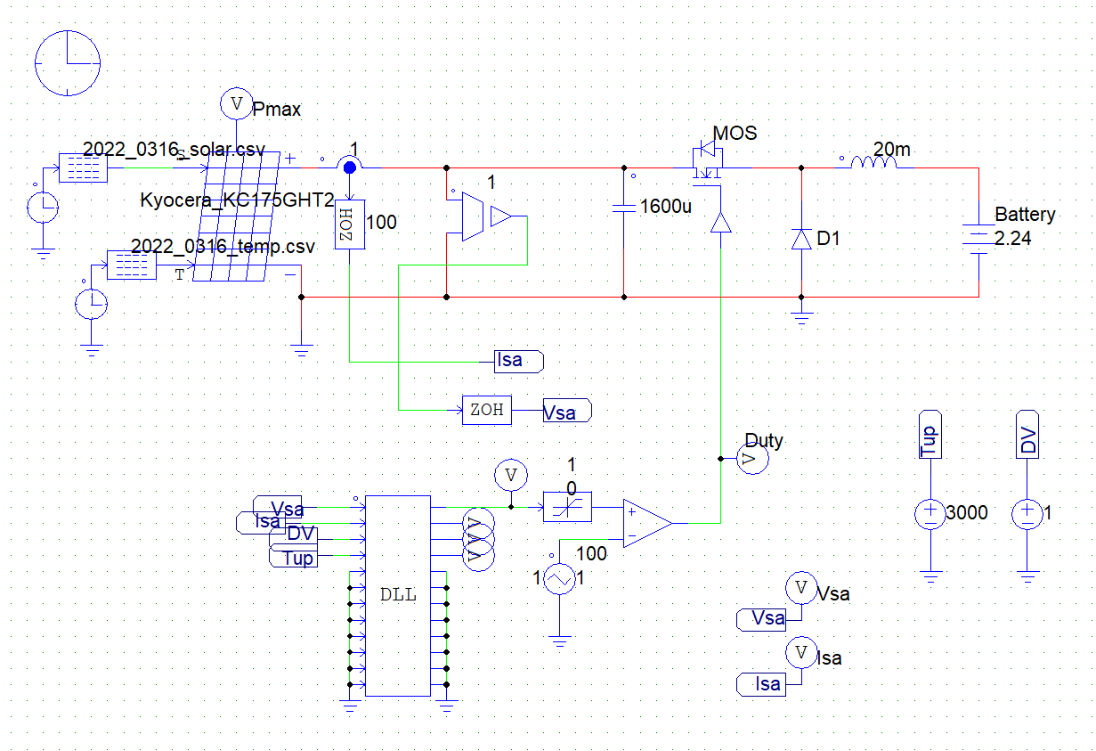

Figure 29. PSIM simulation circuit

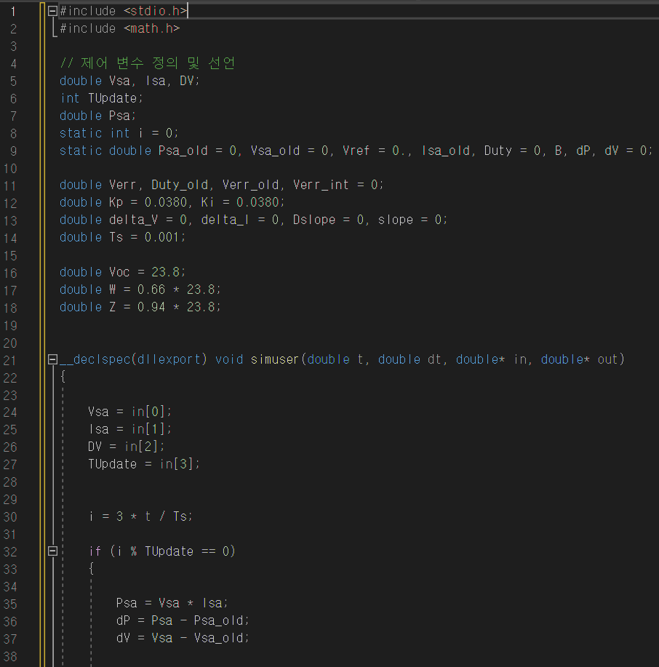

Figure 30. DLL Code_1

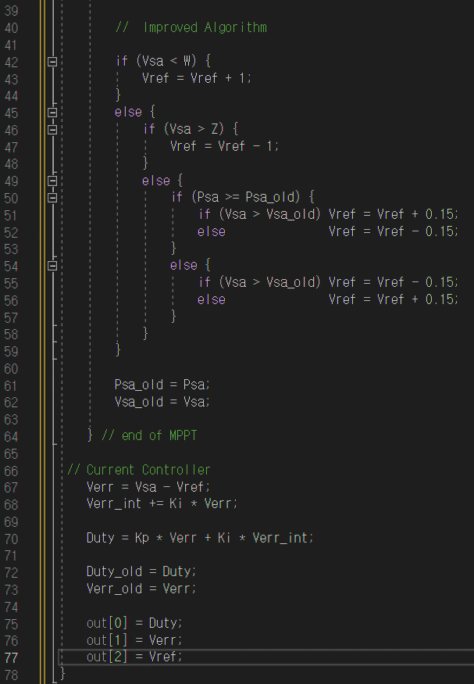

Figure . DLL Code_2

# REFERENCE

[1] Ko Suk-Whan, Jung Young-Seok, So Jung-Hun, Hwang Hye-mi, Ju Young-Chul. (2014). The New MPPT Algorithm for the Dynamic MPPT Efficiency . Journal of the Korean Solar Energy Society, 34(6), None.

[2] Mostafa Ahmed, Ibrahim Harbi, Ralph Kennel, Jose Rodriguez, Mohamed Abdelrahem, An improved photovoltaic maximum power point tracking technique-based model predictive control for fast atmospheric conditions, Alexandria Engineering Journal, Volume 63, 2023, Pages 613-624.

[3] Shivrudraswamy, R., Shukla, A. N., & Chandrakala, C. B. (2017). Design Analysis and Implementation of MPPT Using PSIM. Advances in Smart Grid and Renewable Energy, 157–166. doi:10.1007/978-981-10-4286-7_16

[4] Abdeldjebar Hazzab, Hicham Gouabi, Mohamed Habbab, Miloud Rezkallah, Hussein Ibrahim, Ambrish Chandra, Wind turbine emulator control improvement using nonlinear PI controller for wind energy conversion system: Design and real-time implementation, First published: 23 February 2023.

[5] Mostafa Ahmed, Ibrahim Harbi, Ralph Kennel, Jose Rodriguez, Mohamed Abdelrahem, An improved photovoltaic maximum power point tracking technique-based model predictive control for fast atmospheric conditions, Alexandria Engineering Journal, Volume 63, 2023, Pages 613-624, ISSN 1110-0168

[6] Khodair, D.; Motahhir, S.; Mostafa, H.H.; Shaker, A.; Munim, H.A.E.; Abouelatta, M.; Saeed, A. Modeling and Simulation of Modified MPPT Techniques under Varying Operating Climatic Conditions. Energies 2023, 16, 549.

[7] Mehmet Büyük, Mustafa İnci, Improved drift-free P&O MPPT method to enhance energy harvesting capability for dynamic operating conditions of fuel cells, Energy, Volume 267, 2023, 126543, ISSN 0360-5442.

[8] Fangrui Liu, Yong Kang, Yu Zhang, & Shanxu Duan. (2008). Comparison of P&O and hill climbing MPPT methods for grid-connected PV converter. 2008 3rd IEEE Conference on Industrial Electronics and Applications.